Single Inheritance
#include<iostream>
using namespace std;
#include<string.h>
class person
{
protected:
char name[30];
float age;
public:
void enter(char *nm, float a)
{
strcpy(name,nm);
age=a;
}
void display()
{
cout<<"\nName: "<<name;
cout<<"\nAge: "<<age;
}
};
class employee : public person
{
private:
float salary;
char desig[20];
public:
void enter_data(char *n,char *d,float ag,float s)
{
strcpy(name,n);
strcpy(desig,d);
salary=s;
age=ag;
}
void display_all()
{
cout<<"\nDesignation:"<<desig;
cout<<"\nSalary:"<<salary;
display();
}
};
int main()
{
employee e1,e2;
person p;
e1.enter_data("Rathika" , "Clerk", 32, 5000);
cout<<"\n\n\tEmployee Details ....";
e1.display_all();
e2.enter("Vaskar",41);
e2.display();
cout<<"\nPerson Details .... ";
p.enter("Pragyan",24);
p.display();
return 0;
}

OUTPUT


Program When base and derived class has member func- tions with same name
Two different classes may have member functions with the same name as well as the same set of arguments. But in case of inheritance, an ambiguous situation arises when base class and derived classes contain member functions with the same name. In main(), if we call member function of that particular name of base class with derived class object, then it will always make a call to the derived class member function of that name. This is because, the function in the derived class overrides the inherited function. However, we can invoke the function defined in base class by using the scope resolution operator (::) to specify the class.
#include<iostream>
using namespace std;
class B
{
protected:
int p;
public:
void enter()
{
cout<<"\nEnter an integer:";
cin>>p;
}
void show()
{
cout<<"\n\nThe number in Base Class is:"<<p;
}
};
class D : public B
{
private:
int q,r;
public:
void enter()
{
B::enter();
cout<<"\nEnter an integer:";
cin>>q;
}
void show()
{
r=p*q;
cout<<"\n\nThe product is :"<<r;
}
};
int main()
{
D d;
d.enter();
d.show();
d.B::show();
return 0;
}

OUTPUT
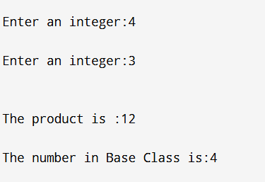

In the program, the function name show() is same in both base “B” and derived class “D”. To call show() of base class “B”, we have used the statement d.B::show(); If we use simply d.show(); then it will invoke show() of derived class “D”. When a derive class implements a function that has the same name as well as the same set of arguments as the function in the base class, it is called function overriding. When such a function is called through a object of derived class, then the derived class function would be invoked. However, that function in base class would remain hidden.

Example of Multiple inheritance
#include<iostream>
using namespace std;
class V
{
protected:
char v;
};
class C
{
protected:
char c;
};
class S //base class
{
protected:
char s;
};
class CHARACTER : public V, public C, public S
{
private:
int n;
public:
void enter() //derived class member function
{
cout<<"\nEnter a vowel:";
cin>>v;
cout<<"\nEnter a consonent:";
cin>>c;
cout<<"\nEnter a symbol:";
cin>>s;
cout<<"\nEnter a number:";
cin>>n;
}
void show()
{
cout<<"\nThe entered characters are";

cout<<"\nVowel: "<<v;
cout<<"\nConsonent: "<<c;
cout<<"\nSymbol: "<<s;
cout<<"\nNumber: "<<n;
}
};
int main()
{
CHARACTER o;
o.enter();
o.show();

return 0;
}
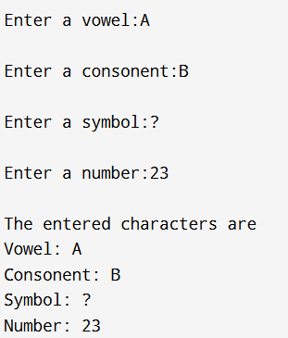

Multipath Inheritance
#include<iostream>
using namespace std;
class B
{
protected:
int b;
};
class D : public B
{
protected:
int d;
};
class E : public B
{
protected:
int e;
};
class F : public D, public E
{
protected:
int f;
public:
void enter_number()
{
cout<<"Enter some integer values for b,d,e,f:";
cin>>b>>d>>e>>f;
}
void display()
{
cout<<"\nEntered numbers are:\n";
cout<<"\nb= "<<b<<"\nd= "<<d<<"\ne= "<<e<<"\nf= "<<f;
}
};
int main()
{ F obj;
obj.enter_number();
obj.display();
return 0;
}
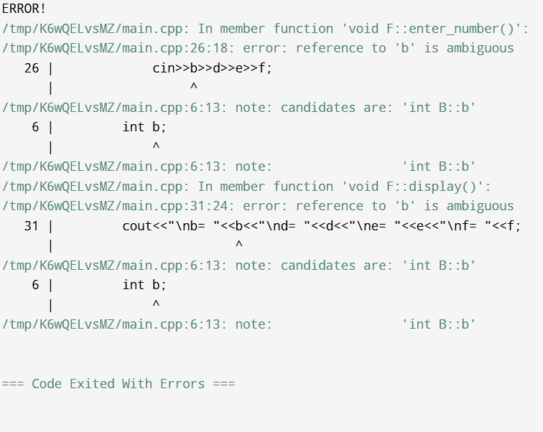
Virtual Base Class
#include<iostream>
using namespace std;
class B
{
protected:
int b;
};
class D:public virtual B
{
protected:
int d;
};
class E:public virtual B
{
protected:
int e;
};
class F : public D, public E
{
protected:
int f;
public:
void enter_number()
{
cout<<"Enter some integer values for b,d,e,f:" ;
cin>>b>>d>>e>>f;
}
void display()
{
cout<<"\nEntered numbers are:\n";
cout<<"\nb= "<<b<<"\nd= "<<d<<"\ne= "<<e<<"\nf= "<<f;
}
};
int main()
{
F obj;
obj.enter_number();
obj.display();
return 0;
}
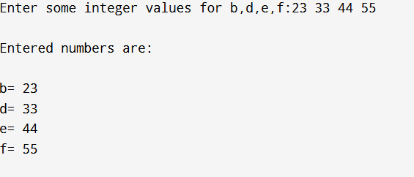
Here we have used the keyword virtual in front of the base class specifiers to indicate that only one subobject of type B, shared by class D and class E, exists.. When a class is made a virtual base class, C++ takes the necessary action that only one copy of that class is inherited, regardless of how many paths exist between the virtual base class and a derived class.

Virtual Function
This program demonstrates how a virtual function ensures that the derived class's function is called, even when accessed via a base class pointer.
#include <iostream>
using namespace std;
class Base {
public:
virtual void show()
{
cout << "Base class show function" ;
}
};

class Derived : public Base
{
public:

void show()
{
cout << "Derived class show function" << endl;
}
};

int main() {
Base* basePtr; // Pointer of base class
Derived derivedObj; // Object of derived class
basePtr = &derivedObj; // Base class pointer points to derived class object
basePtr->show(); // Calls Derived class's show() due to virtual function
return 0;
}

Abstract Class
In C++, an abstract class serves as a blueprint for other classes. It's characterized by the presence of at least one pure virtual function—a function declared by appending = 0 to its declaration, indicating that derived classes must override this function
Key Characteristics of Abstract Classes:
- Cannot Be Instantiated: You cannot create objects of an abstract class directly.
- Mandatory Overriding: Derived classes must override all pure virtual functions of the abstract base class.
- Supports Polymorphism: They allow for dynamic dispatch, enabling function calls to be resolved at runtime based on the object's actual type.

#include <iostream>
using namespace std;
class Shape
{
public:
virtual void draw() = 0;
virtual ~Shape() {}
};

class Circle : public Shape
{
public:
void draw()
{
cout << "Drawing a circle." ;
}
};

class Square : public Shape
{
public:
void draw()
{
cout << "Drawing a square." ;
}
};

int main() {
Shape* shape1 = new Circle();
Shape* shape2 = new Square();

shape1->draw(); // Outputs: Drawing a circle.
shape2->draw(); // Outputs: Drawing a square.

delete shape1;
delete shape2;

return 0;
}
OUTPUT
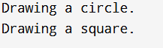

Function Overloading
#include <iostream>
using namespace std;
int add(int a, int b)
{
return a + b;
}

int add(int a, int b, int c)
{
return a + b + c;
}
double add(double a, double b)
{
return a + b;
}

int main()
{
int intResult = add(10, 20);
int intResult3 = add(10, 20, 30);
double doubleResult = add(10.5, 20.3);
cout << "Addition of two integers: " << intResult ;
cout << "Addition of three integers: " << intResult3 ;
cout << "Addition of two doubles: " << doubleResult;
return 0;
}
OUTPUT
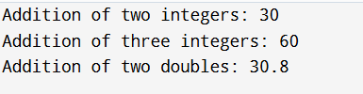

Binary Operator Overloading Without Friend Function
- The binary operator is overloaded as a member function.
- The left operand must be an object of the class.
Example: Overloading + Operator (Addition)

#include <iostream>
using namespace std;
class Complex {
private:
int real, imag;
public:
// Constructor
Complex(int r = 0, int i = 0) : real(r), imag(i) {}

// Overloading + operator as a member function

Complex operator+(const Complex& obj)
{
return Complex(real + obj.real, imag + obj.imag);
}

void display()
{
cout << real << " + " << imag << "i" << endl;
}
};

int main()
{
Complex c1(3, 4), c2(1, 2);

Complex c3 = c1 + c2; // Calls overloaded + operator

cout << "Sum of Complex Numbers: ";
c3.display();

return 0;
}
OUTPUT
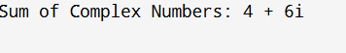

Binary Operator Overloading Using Friend Function
- The binary operator is overloaded using a friend function.
- The function takes two objects as arguments.
Example: Overloading + Operator (Addition) Using Friend Function
#include <iostream>
using namespace std;
class Complex
{
private:
int real, imag;
public:
// Constructor
Complex(int r = 0, int i = 0) : real(r), imag(i) {}

// Friend function to overload +
friend Complex operator+(const Complex& c1, const Complex& c2);

void display()
{
cout << real << " + " << imag << "i" << endl;
}
};

// Definition of friend function
Complex operator+(const Complex& c1, const Complex& c2)
{
return Complex(c1.real + c2.real, c1.imag + c2.imag);
}

int main()
{
Complex c1(5, 7), c2(2, 3);
Complex c3 = c1 + c2; // Calls overloaded + operator
cout << "Sum of Complex Numbers: ";
c3.display();
return 0;
}
OUTPUT
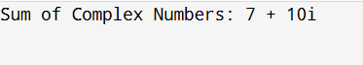
Unary Operator Overloading in C++
Unary operators operate on a single operand. They can be overloaded using:
- Without Friend Function (Member Function)
- With Friend Function (Non-Member Function)

Unary Operator Overloading Without Friend Function
- The unary operator is overloaded as a member function.
- The function does not take any arguments.

Example: Overloading - (Negation) Operator
#include <iostream>
using namespace std;

class Number
{
private:
int value;
public:
Number(int v = 0) : value(v) {}

// Overloading unary - operator as a member function
void operator-()
{
value = -value;
}
void display()
{
cout << "Value: " << value;
}
};

int main()
{
Number num(5);
<< "\nBefore Overloading:";
num.display();

-num; // Calls overloaded - operator
cout << "\nAfter Overloading:";
num.display();
return 0;
}
OUTPUT
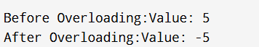
Unary Operator Overloading Using Friend Function
- The unary operator is overloaded using a friend function.
- The function takes an object as an argument since it is non-member.
Example: Overloading - (Negation) Operator with Friend Function
#include <iostream>
using namespace std;
class Number {
private:
int value;
public:
Number(int v = 0) : value(v) {}

// Declaring friend function for unary - operator
friend Number operator-(const Number& num);

void display()
{
cout << "Value: " << value << endl;
}
};

// Definition of friend function
Number operator-(const Number& num)
{
return Number(-num.value); // Returning new object with negated value
}

int main()
{
Number num(8);
cout << "Before Overloading:" ;
num.display();
Number negNum = -num; // Calls overloaded - operator
cout << "After Overloading:" ;
negNum.display();
return 0;
}
OUTPUT
